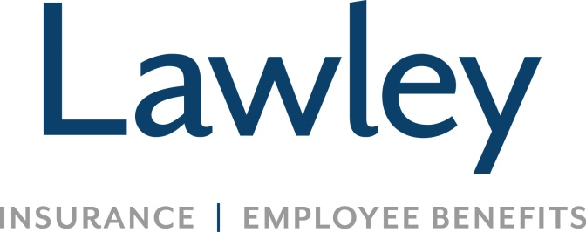

**Commercial Insurance Claims Consultant**

**Position Focus:**

* First reporting of claims, extending full courtesy and help to clients and third party claimants
* Reviewing coverage denials to determine the exclusions are appropriate and negotiating favorable resolutions with the carrier and the client
* Reviewing accounts for adequate coverage and recommending appropriate coverage to account manager
* Conducting open claim review and following up on open claim diaries to insure proper handling or settlement
* Support all Lawley initiatives as requested, guided by company values, sales culture, business needs and scorecard

**Successful candidates possess:**

* At least three years of experience in a similar or related position
* Relevant knowledge of commercial lines claims adjustment and evaluation process
* Microsoft Office experience and skills are a must; EPIC experience preferred
* Incredible attention to detail and organizational skills
* Ability to work well independently and on a team
* Property/Casualty license and/or claims-related designation preferred
* Open to continuing education, Associate degree or higher preferred
* Positive attitude, even in a fast paced environment
* A passion to make customers and coworkers feel important and valued
* Capability to work quickly and efficiently
* Methodical, yet swift decision making skills
* Precise verbal and written communication skills, even under time constraints

**What’s in it for you? *The Lawley Advantage!***

* Fulfilling career securing your clients’ well being
* Competitive salary, referral bonuses **AND** annual bonus eligibility
* Great Benefits (Medical, Dental, Vision-- the works!)
* Educational and growth opportunities
* Generous PTO and 401K upon hire
* Comfortable, family oriented culture
* Office hours 8-4:30
* Lawley is not a call center environment
* Work hard, play hard!!!