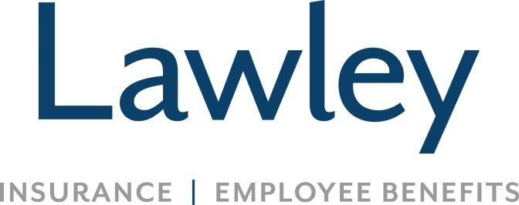

**Position Focus:**

**Lead Payroll Administrator**

* Maintains a semi-monthly 350+ associate, multi-state payroll, of 2 payroll groups and employee benefit-related costs in ADP
* Supervises and mentors team member (Payroll Specialist), approves inputs and updates for associate and payroll system (ADP) with all changes to employee benefit information ensuring agreement with the Benefits Management System (PlanSource)
* Works as part of a team that reviews and analyzes 401k plan performance with CFO and carriers to identify improvements including fund options and changes
* Coordinates annual 401k compliance testing, information gathering, and Department of Labor filings (Form 5500’s) as required
* Coordinates 401k contributions with plan administrator including downloading and calculating company contributions and coordinates annual 401k retirement plan audit
* Captures necessary information to properly account for ACA reporting
* Handles workers’ compensation and life insurance claims and filings
* Maintains accurate plan documents for all employee benefit plans, as it relates to ERISA standards and regulations
* Processes and reconciles employee benefit (Medical, Dental, Vision, and Cobra) payments to carriers and updates monthly benefit reports with charges
* Compiles taxable fringe benefit information for inclusion in W-2’s
* Assists in the preparation of monthly staffing report
* Balances payroll general ledger accounts by resolving payroll discrepancies
* Maintains payroll guidelines by writing and updating policies and procedures
* Maintains professional and technical knowledge by attending educational workshops and reviewing professional publications
* Is a committee member for the annual Lawley United Way campaign
* Support all Lawley initiatives as requested, guided by company values, sales culture, business needs, and scorecard

**Successful candidates possess:**

* Bachelor’s degree or equivalent experience
* Minimum of 3-5 years in a similar or related position
* Payroll and 401k administration experience
* Ability to be a senior “go to” person as well as lead others by assigning tasks for project planning and completion
* Advanced MS Word, Excel, Access proficiency are a must! Experience with ADP (EZ Labor) preferred
* Ability to work well independently and on a team
* Incredible attention to detail and organizational skills
* Ability to learn quickly, expand tasks to create meaning, and develop knowledge through experience
* Positive attitude, even in a fast-paced environment
* A passion to make customers and coworkers feel important and valued
* Capability to work quickly and efficiently
* Dependability and ability to exercise confidentiality
* Precise communication skills, even under time constraints

**What’s in it for you? The Lawley Advantage!**

• Fulfilling career securing your clients’ well being

• Competitive salary, referral bonuses, AND annual bonus eligibility

• Great Benefits (Medical, Dental, Vision-- the works!)

• Educational and growth opportunities

• Generous PTO and 401K upon hire

• Office hours 8-4:30; Comfortable, family-oriented culture

• Lawley is not a call center environment

• Work hard, play hard!!!

*Lawley provides equal employment opportunities (EEO) to all employees and applicants for employment without regard to race, color, religion, sex, national origin, age, disability or genetics.*