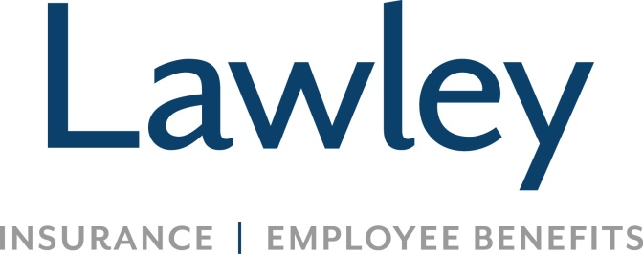

**Commercial Insurance Account Manager**

**Position Focus:**

* Manage an established book of business assigned specifically to you which would include renewals, providing summaries, ordering and issuing binders, certificates, policies, proposals and other insurance documents within designated timelines
* Conduct consultative conversations with a Commercial client base; establish & maintain carrier relationships
* Obtaining non-marketed renewal quotes from existing carriers, completing renewal processes and handle non-renewal and cancellations for cause; prepare complete marketing submissions on existing clients as needed
* Support all Lawley initiatives as requested, guided by company values, sales culture, business needs and scorecard

**Successful candidates possess:**

* Insurance experience in customer service or account management for 3 years or more
* Property/Casualty License (all lines)
* Relevant knowledge of insurance products, documents and usages
* Computers skills are a must! Word, Excel and Outlook. Applied/EPIC experience is preferred
* Ability to work well independently and on a team
* Incredible attention to detail and organizational skills
* Open to continuing education, college degree or equivalent industry designations
* Positive attitude, even in a fast paced environment
* A passion to make customers and coworkers feel important and valued
* Capability to work quickly and efficiently
* Methodical, yet swift decision making skills
* ****Precise communication skills, even under time constraints

**What’s in it for you? *The Lawley Advantage!***

* Fulfilling career securing your clients’ well being
* Competitive salary, referral bonuses **AND** annual bonus eligibility
* Great Benefits (Medical, Dental, Vision-- the works!)
* Educational and growth opportunities
* Generous PTO and 401K upon hire
* Comfortable, family oriented culture
* Office hours 8-4:30
* Lawley is not a call center environment
* Work hard, play hard!!!